NAME: Mukesh Raj L
REG NO:- 192571036

UMBRELLO EXPERIMENTS
EX 06 - Online Food Delivery Platform using Umbrello
AIM:
Design a Class Diagram, Use case Diagram and Activity Diagram for the Online Food Delivery System showing the relevant classes, their attributes, methods, and relationships.

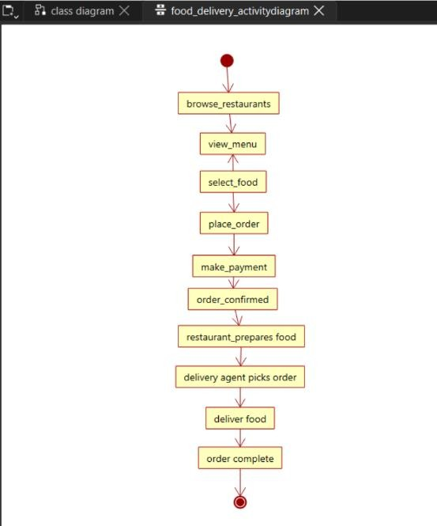
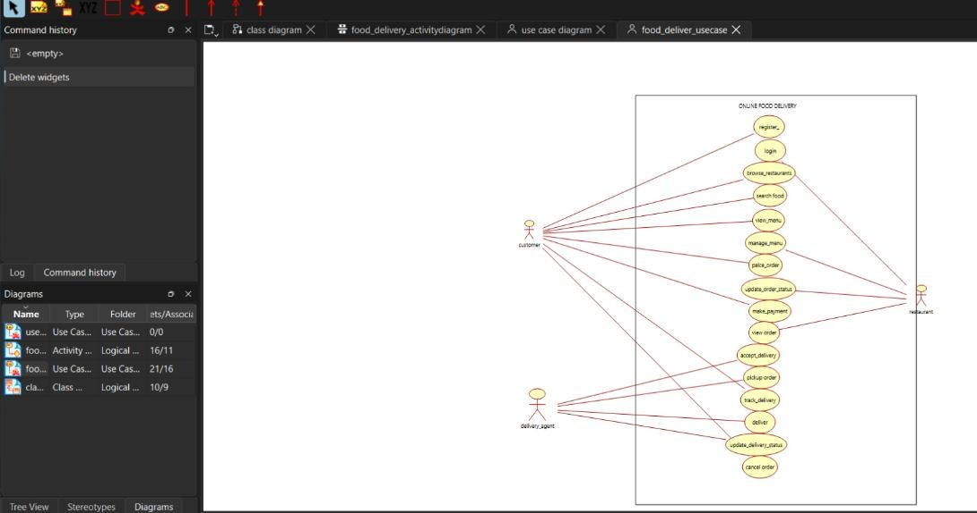
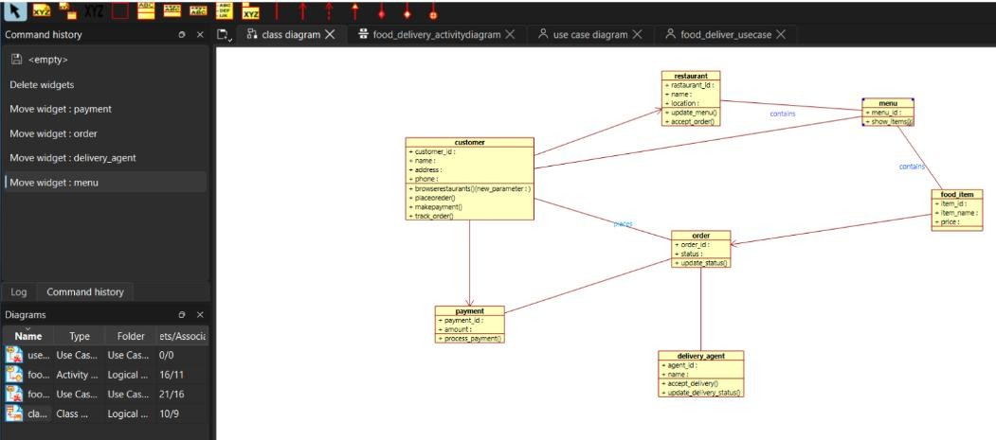

EX07 - Online Security Management System using Umbrello
AIM:-
Develop Class Diagram, Use case Diagram and Activity Diagram to represent the workflow of the Online Security Management System.

